**Setter dan Getter**

Faishal Hanif Ramadhani – 14 – X RPL 4

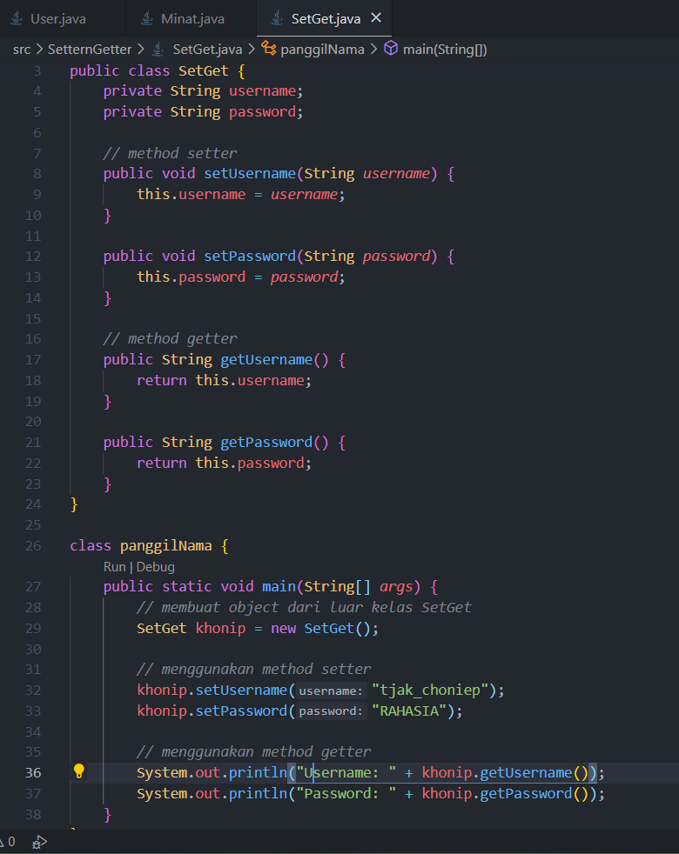

Output:

